**User Manual**

Project 2: DB backend web application

University management system

Team:

[Poorna Raavi](mailto:raavip@clarkson.edu)[Shiva Prasad Reddy Govindagari](mailto:govind@clarkson.edu)[Swati Kar](mailto:kars@clarkson.edu)

[Sowjanya Butukuru](mailto:butukus@clarkson.edu)[Vardhan Kumar Pokala](mailto:pokalav@clarkson.edu)

**Introduction**:

Welcome to the Clarkson University Management System (CUMS) user manual. This manual serves as a comprehensive guide for users interacting with the CUMS platform, designed to streamline administrative, instructional, and student-related tasks within Clarkson University. Whether you are an administrator, instructor, or student, this manual provides detailed instructions and insights into navigating the system effectively.

**Log in:**

Login form has three options: Admin, Instructor and Student. To get access, the user must have to provide correct credentials and select his role.

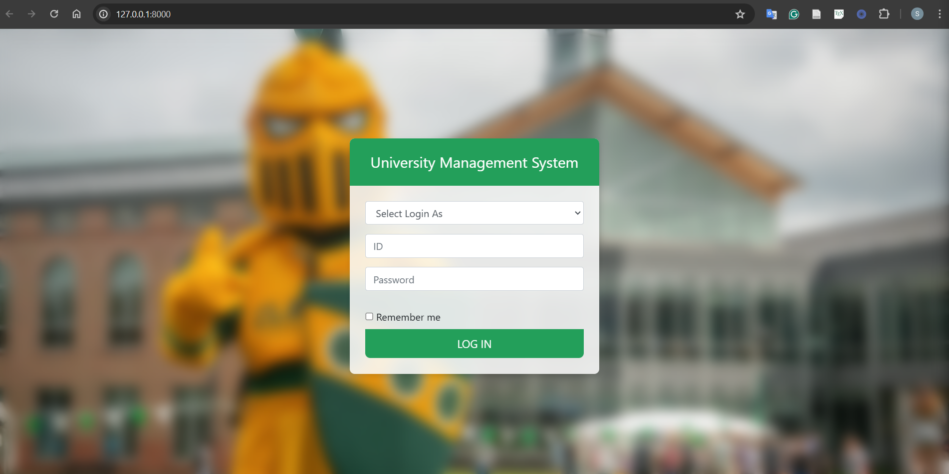

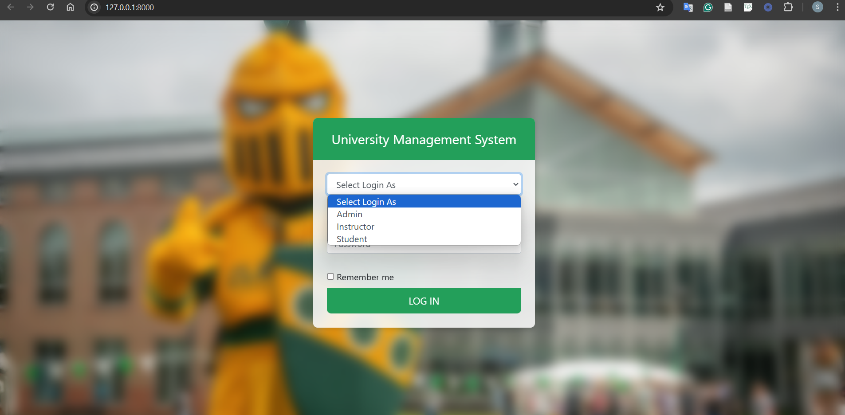

**Login as Admin:**

If wrong credentials are provided, the user will get the following error and not be able to log in.

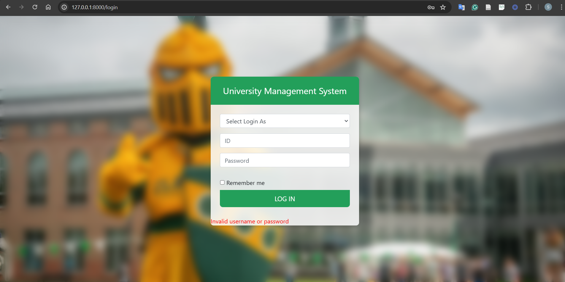

If correct credentials are provided, user will be able login as ‘Admin’

**Admin Dashboard:**

This is an admin dashboard from where admin will be able to see his features.

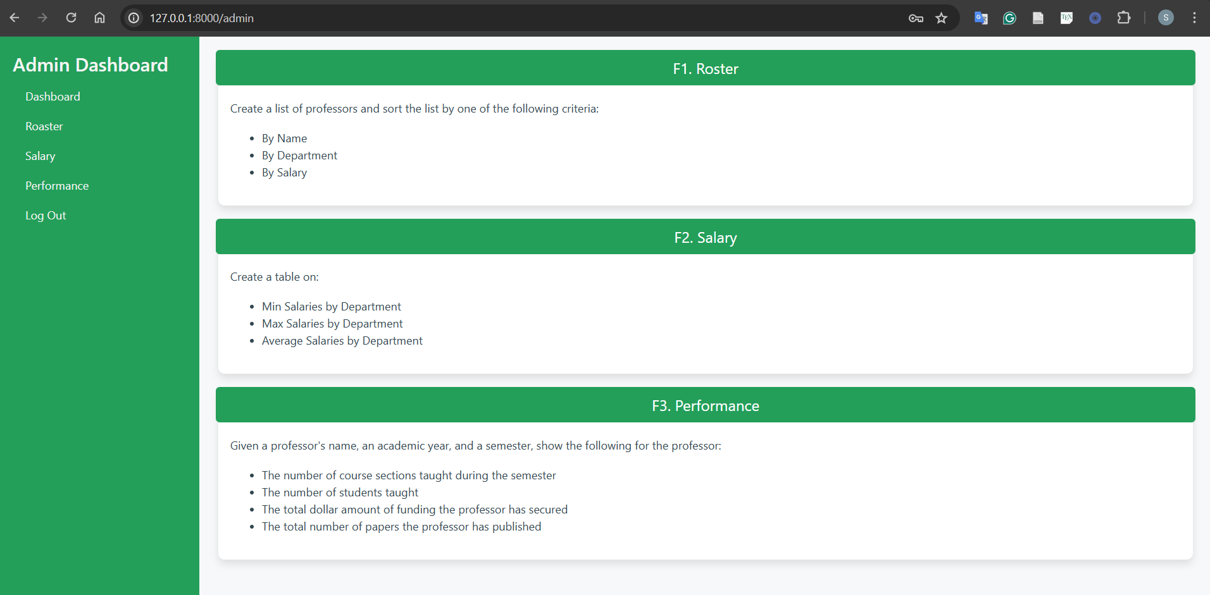

**F1 Roaster:**

In the roaster option, a list is shown with all the information about a professor i.e. Professor ID, Name, department, and salary.

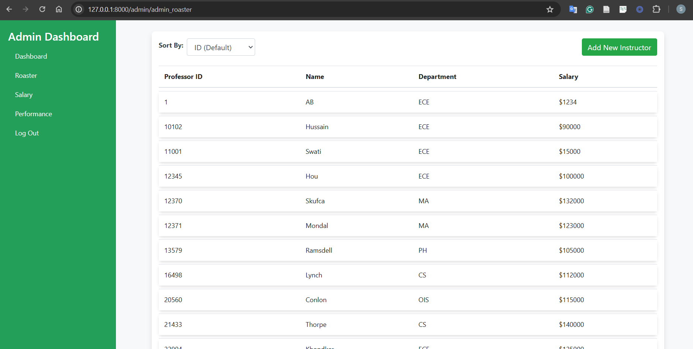

Admin should be able to sort the list by name, department and salary.

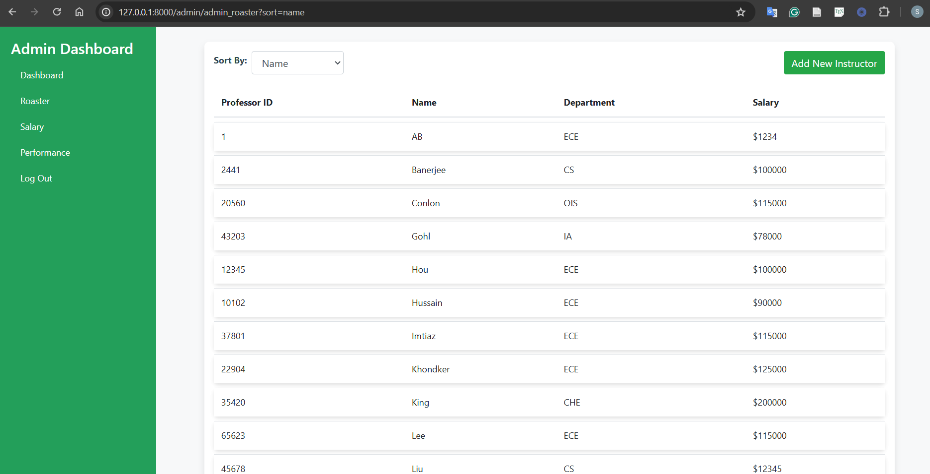

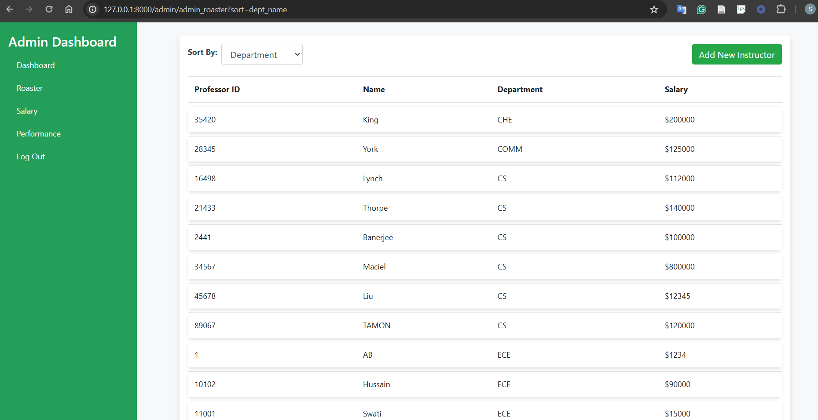

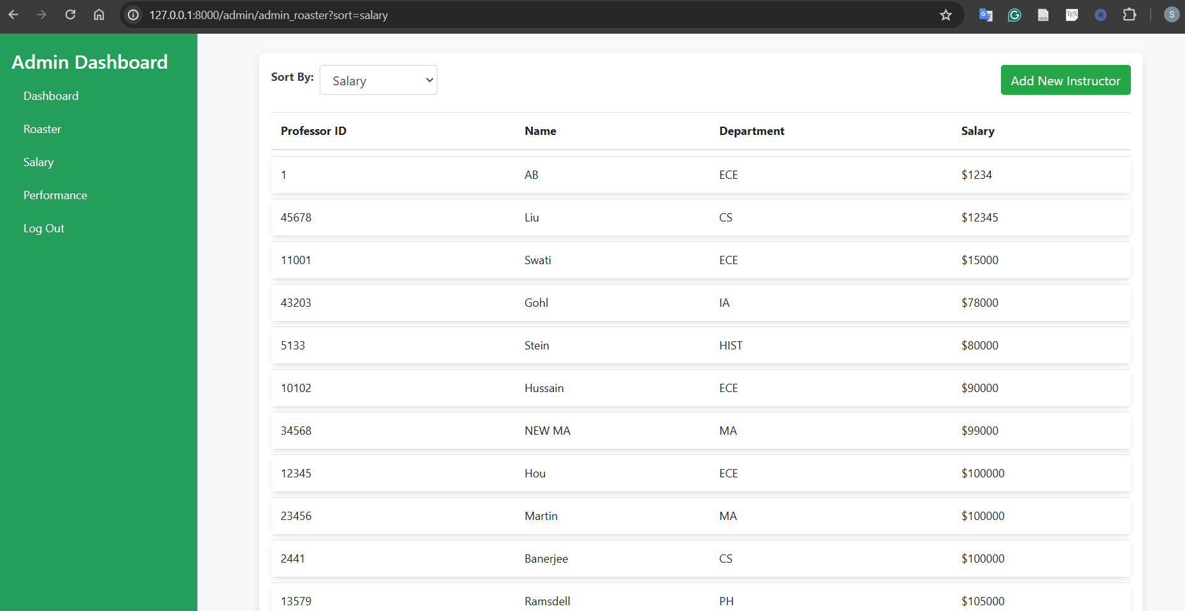

**F2 Salary:**

Admin should be able to see min/max/avg salaries by department.

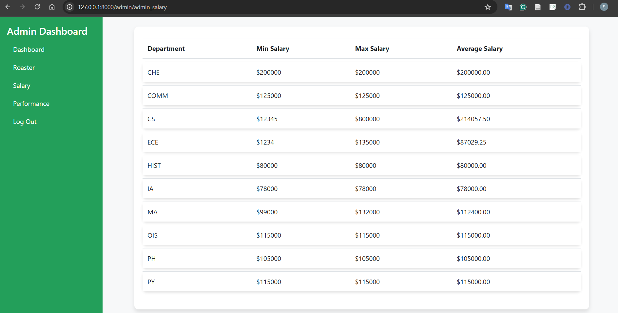

**F3 Performance:**

Given the professor's name, academic year and semester the admin will be able to see the number of courses, number of students the professor teaches and total funding, papers published by the professor**.**

**Input:**

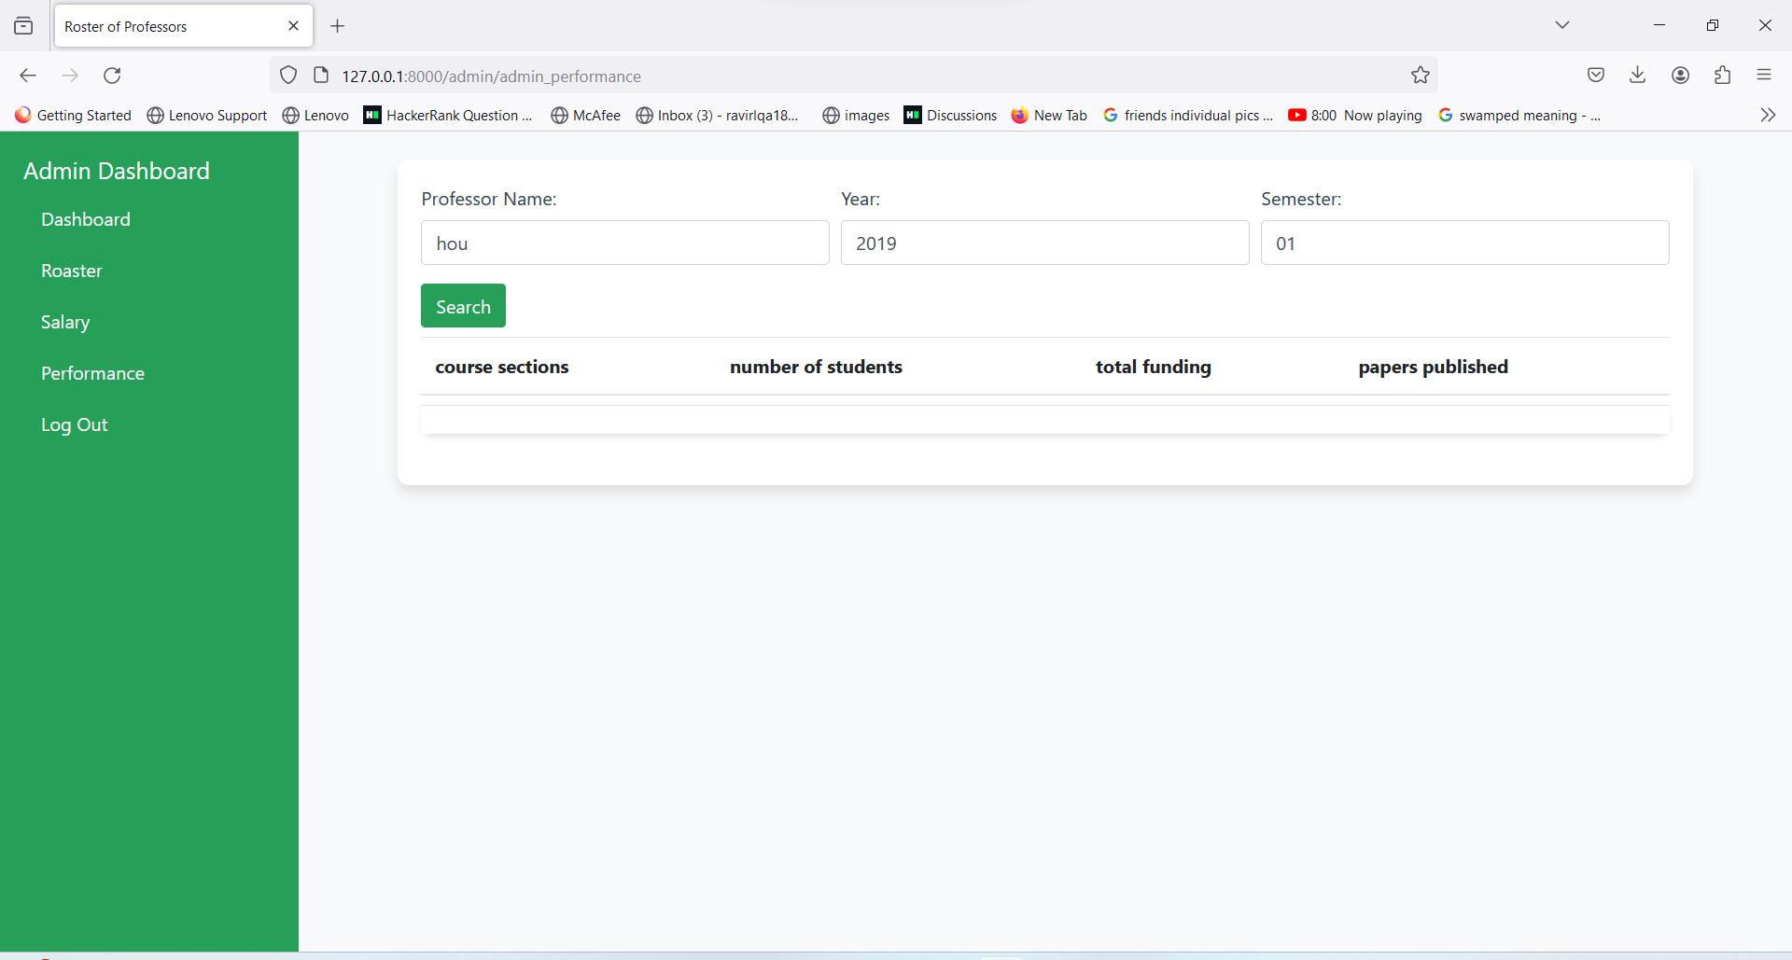

**output:**

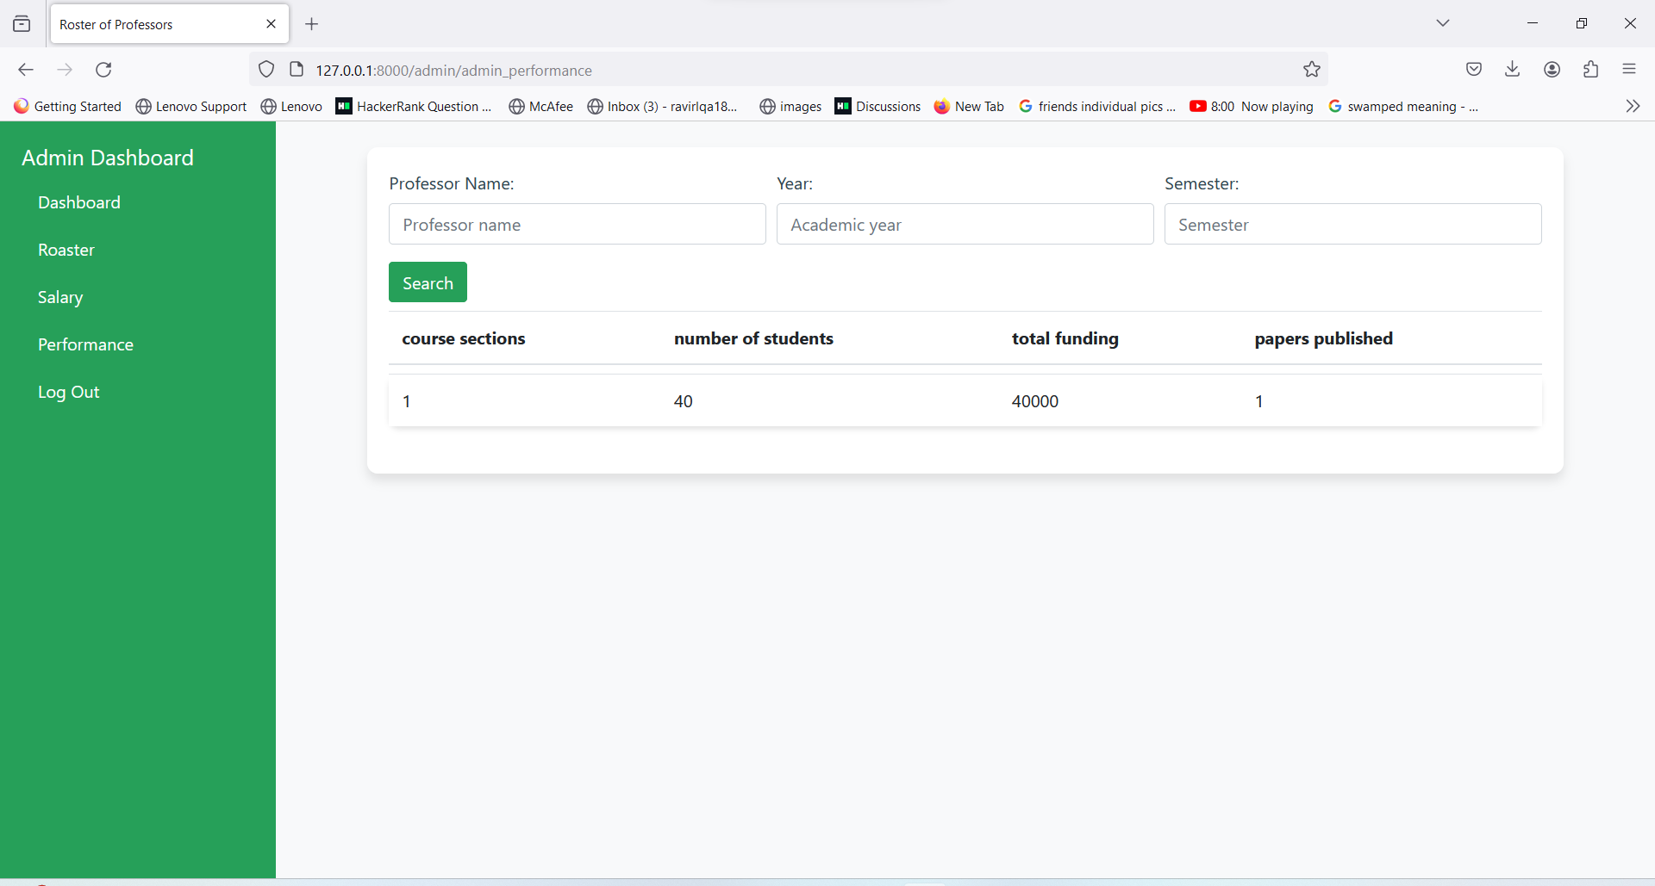

**Login as “Instructor”**

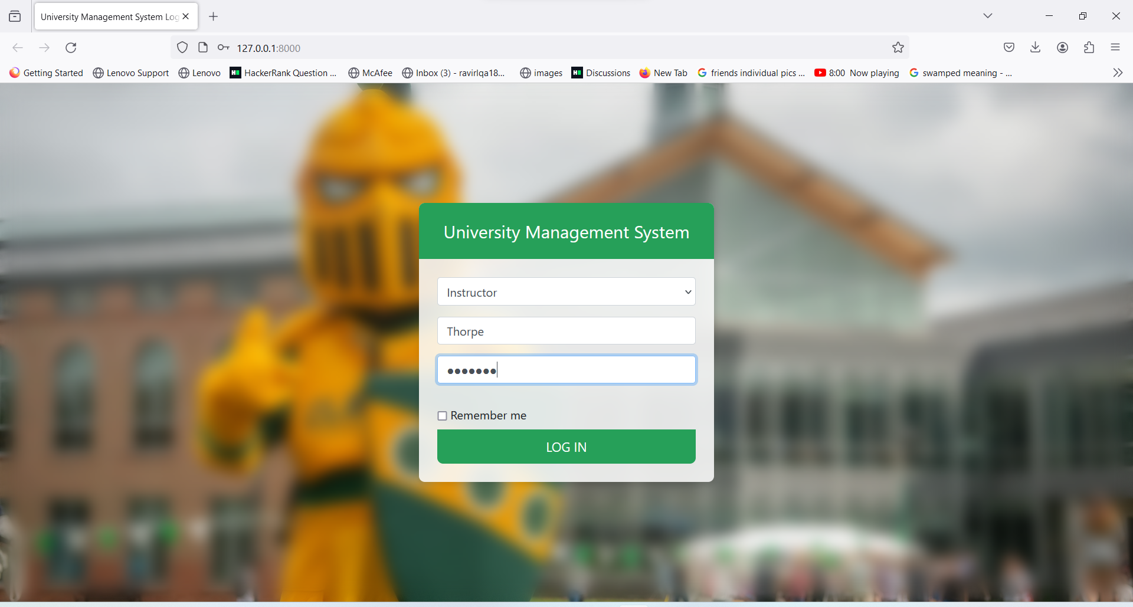

**Instructor dashboard**

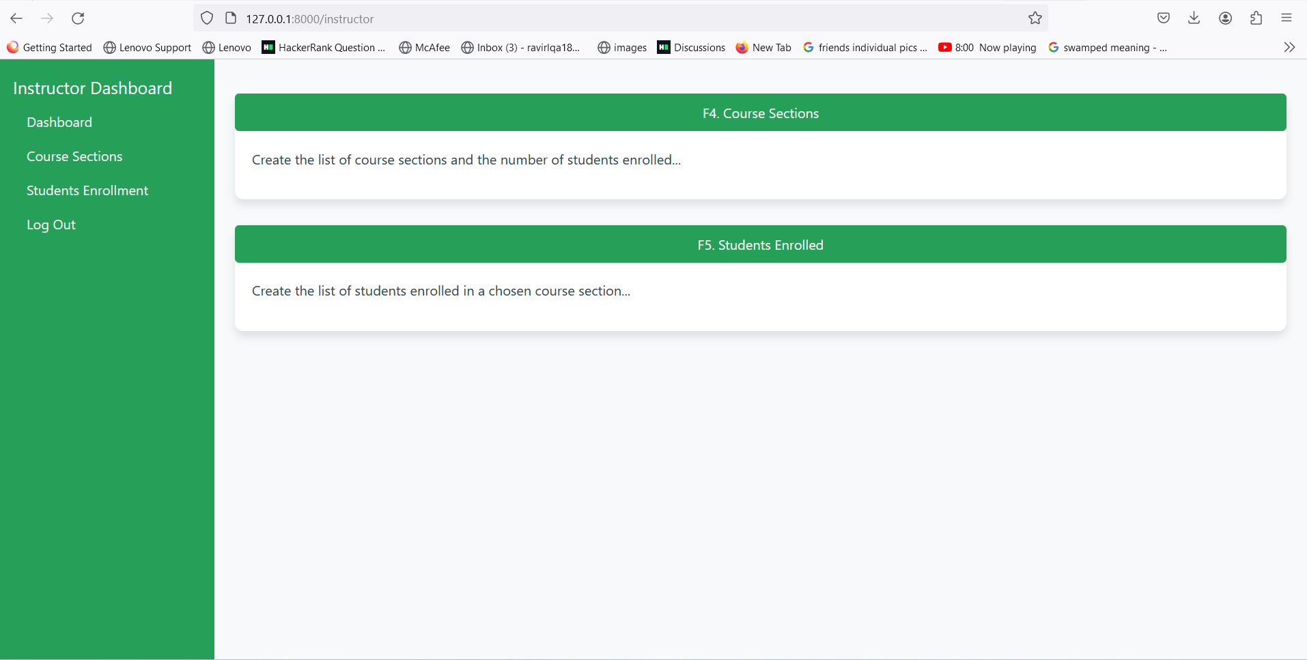

When the logged in user is an instructor, the “instructor dashboard” is landed, which is different from admin & student dashboard. The instructor “Thorpe” here for example can only see his/her data and is not allowed to access other instructors data.

**F4: Course Sections**

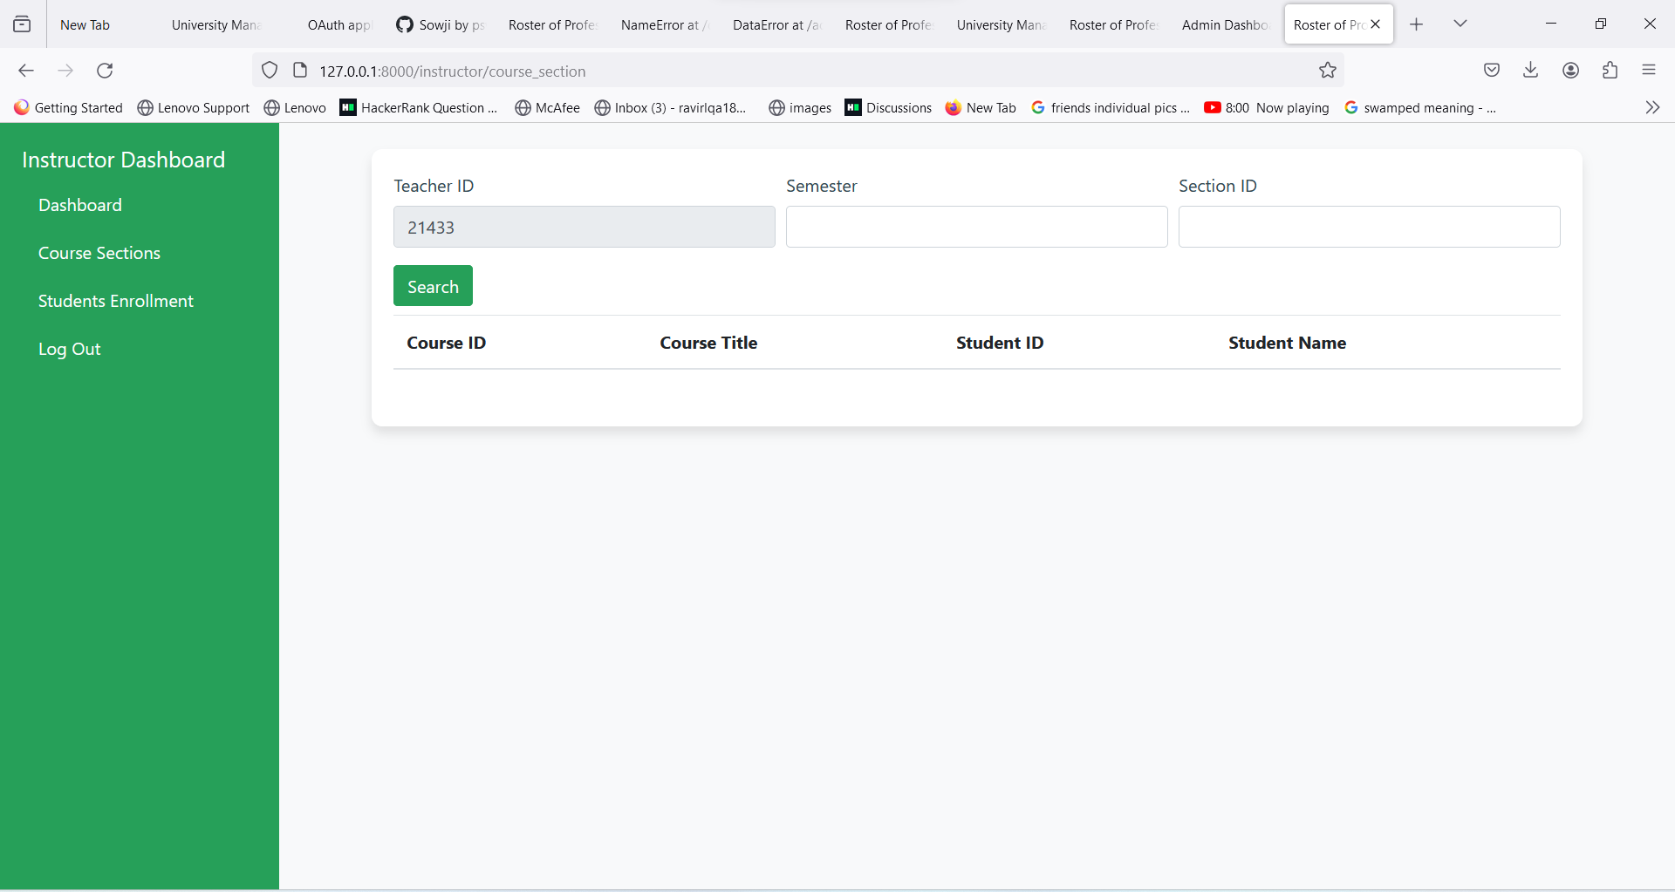

The Instructor has two items on the Instructor dashboard, they are “course sections” and “students enrollment”.

Upon clicking on “course sections”, the user is redirected to the course_sections page, where there are 3 fields on top of the page, teacher ID, semester and section ID. The instructor needs to enter the section ID and semester to get a list of course sections and the number of students enrolled in each section. In the result of list the student_id, names are printed as well.

**Input**: Teacher ID is fetched from the instructor who logged in. It is not an editable field. If you give semester=1, section ID= 02 and hit search you will get a list of course sections and students enrolled in section 02 for semester 1 taught by professor teacherID 21433( who is prof. Thorpe check login page above)

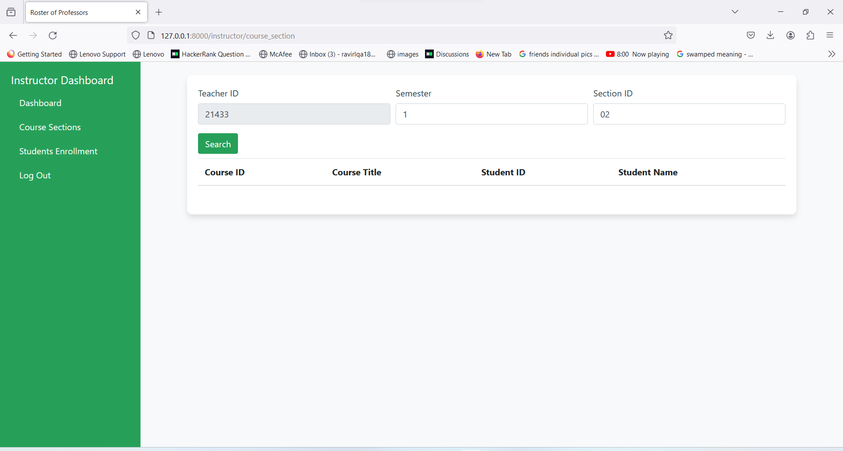

**Output**:

The following is the list of course sections(course id, title) and students(ID, name) enrolled in a given semester and section for course taught by instructor whose ID = 21433

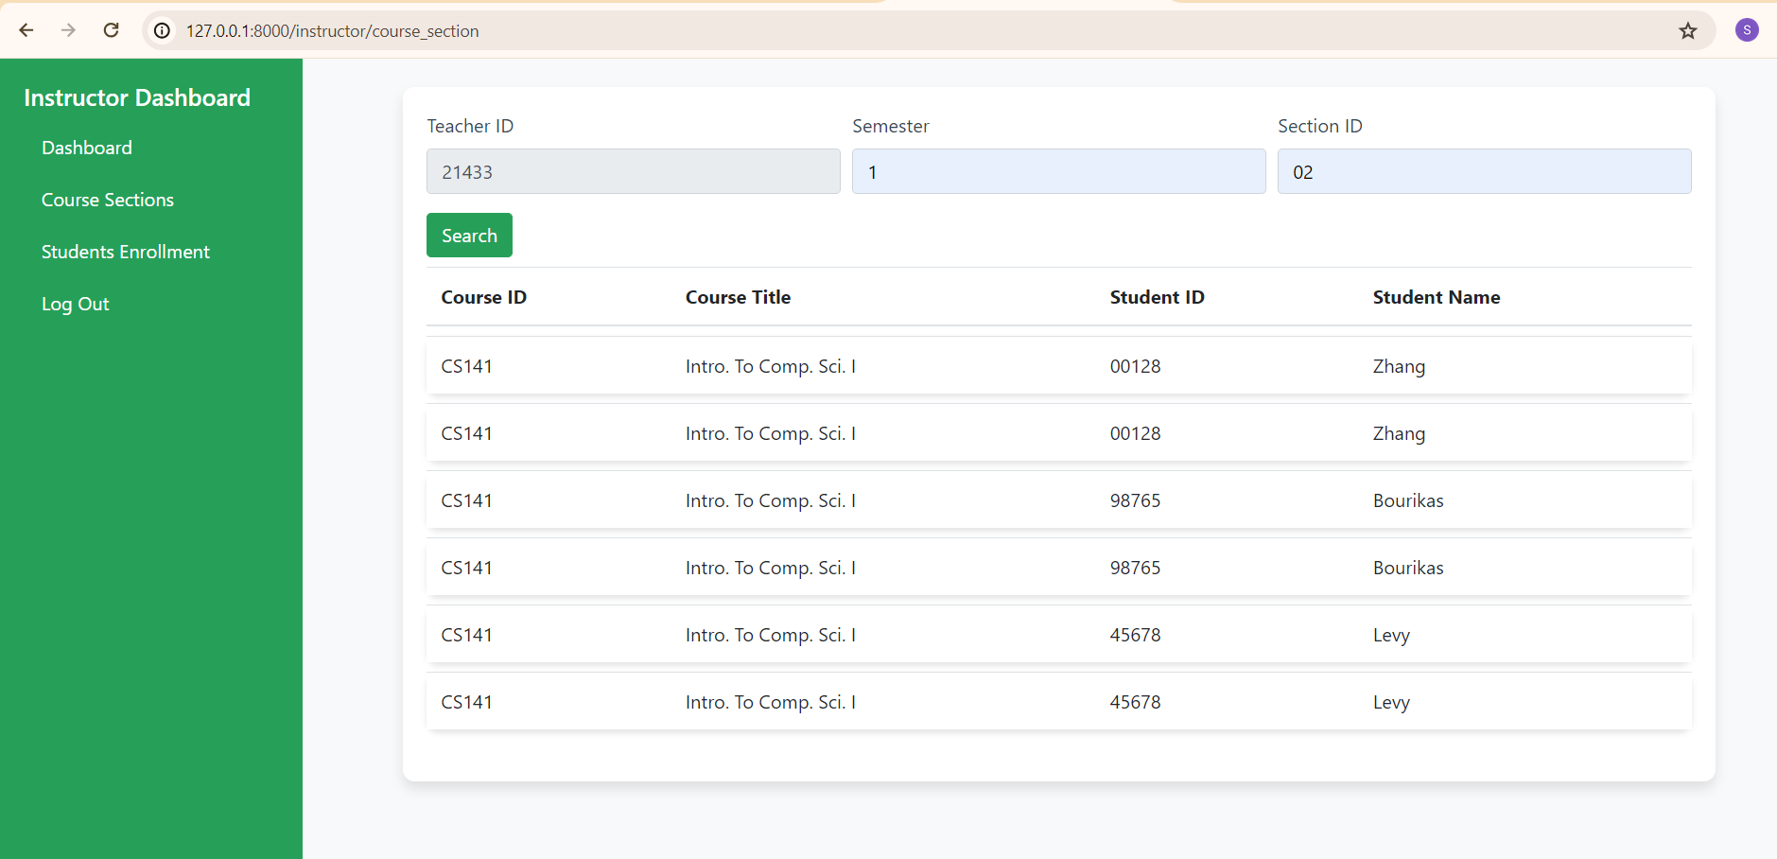

**F5: Student Enrollment**

The F5 student enrollment feature allows the instructor to list the number of students enrolled for a particular course in a given semester.

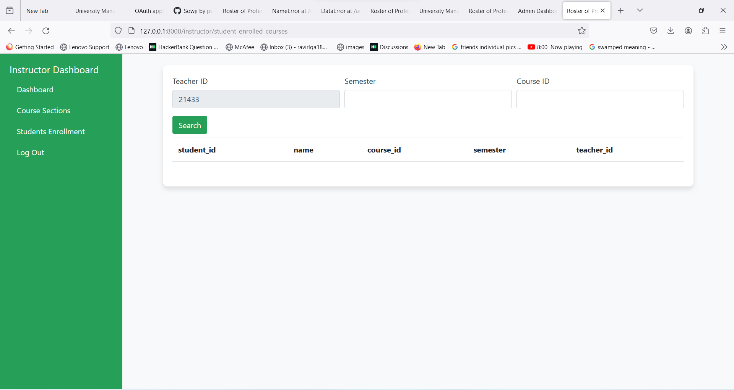

There are 3 fields on top of the page, teacher ID, semester and course ID. The instructor needs to enter the course ID and semester to get the list of the number of students enrolled in that course for a given semester. In the result of list the student_id, names are printed as well.

**Input**: Teacher ID is fetched from the instructor who logged in. It is not an editable field. If you give semester=1, course ID= 141 and hit search you will get a list of students enrolled in cs141 for semester 1 taught by professor teacherID 21433( who is prof. Thorpe check login page above)

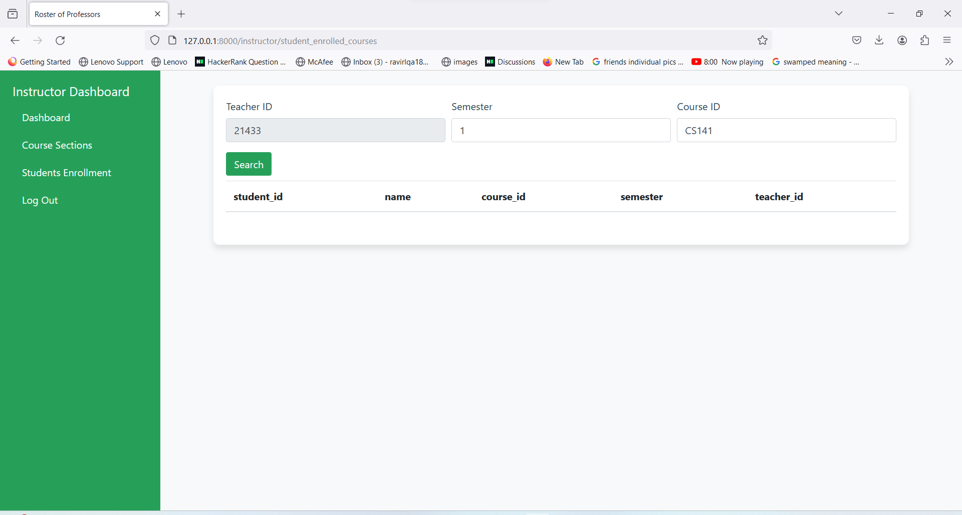

**Output**:

The following is the list of student enrolled in a given semester for course is taught by instructor whose ID = 21433

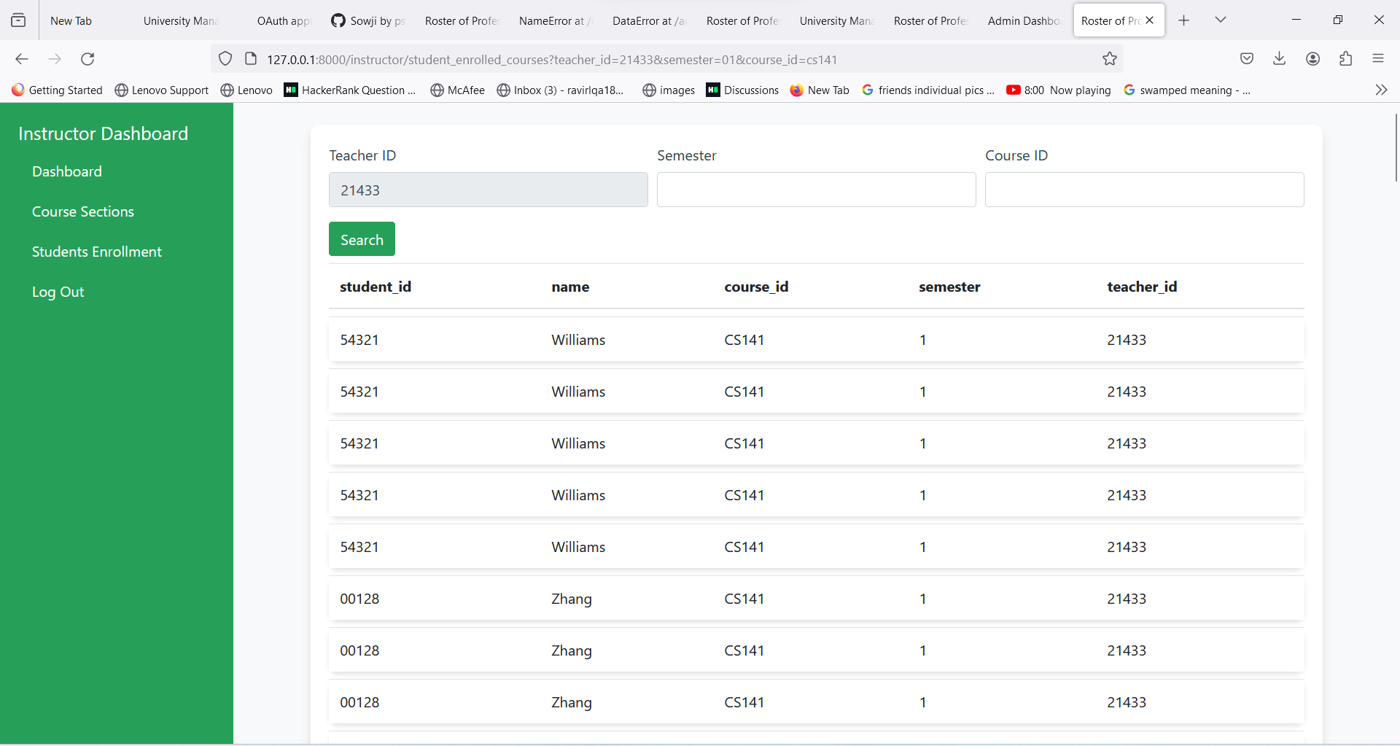

Instructor can move to the “course sections” page by clicking on the item in the dashboard. “Instructor Dashboard” panel on the left helps users to navigate through different sections. On clicking log out the instructor is logged out from the current page and taken back to the login page

**F6: Student**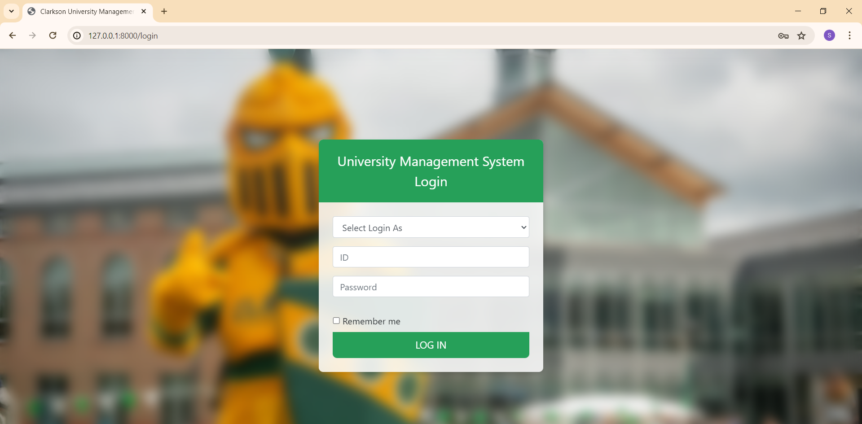

When a student navigates to the login page, they will encounter the above dialog box, which enables them to select and enter details to log in to the website.

Select "student" from the 'Select Login As' dropdown menu, then enter your student name and password into the respective 'ID' and 'password' text boxes. Finally, click 'Login' to proceed.

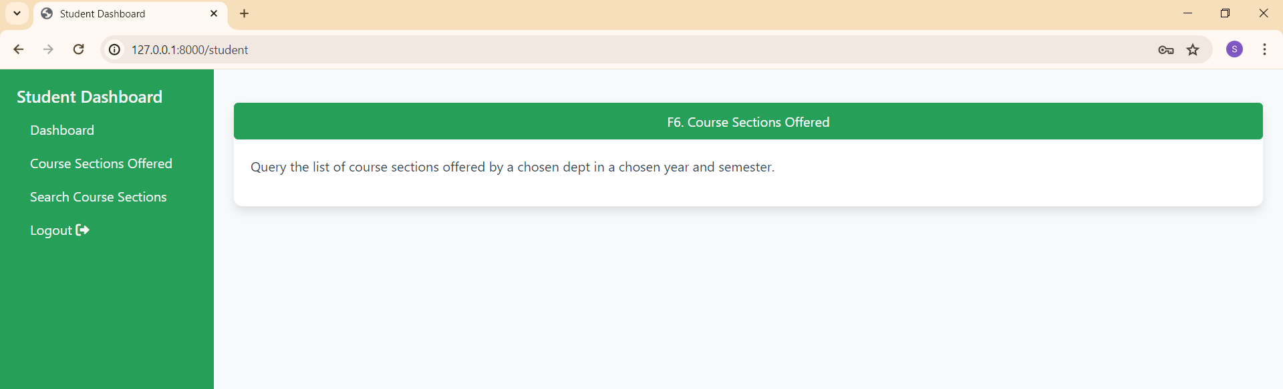

After providing valid credentials, you will be redirected to the student dashboard. Here, you'll find a navigation bar with useful links on the left side of the page, and information about Feature 6 functionality on the right side.

Navigation bar:

Dashboard: Clicking on this link will direct you to the 'Student Dashboard' page.

Course Sections Offered: Clicking on this link will redirect you to the 'courseSection_list' page, where you can view the list of available course sections.

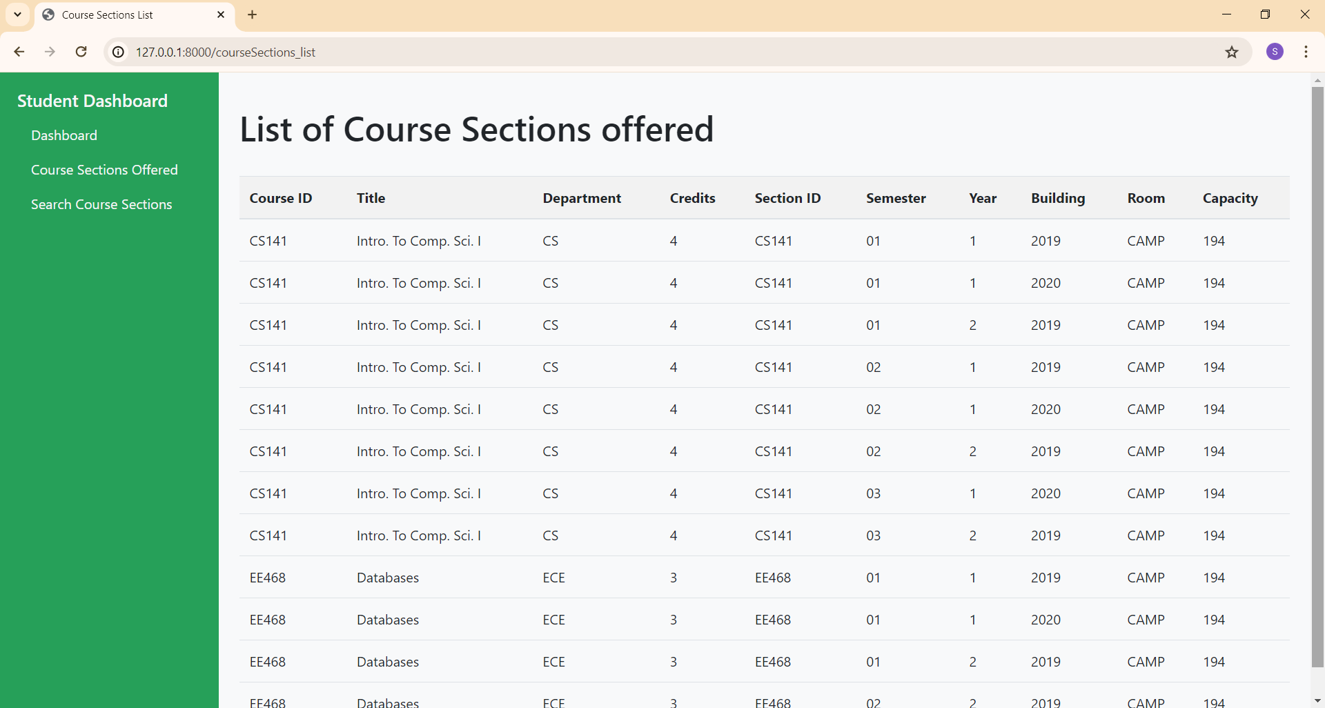Search Course Sections: Clicking on this link will enable a student to search the list of course sections offered by selecting a department, year, and semester.

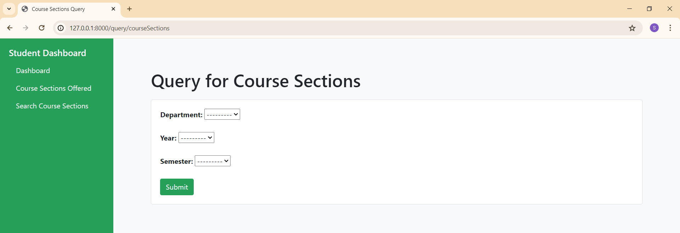

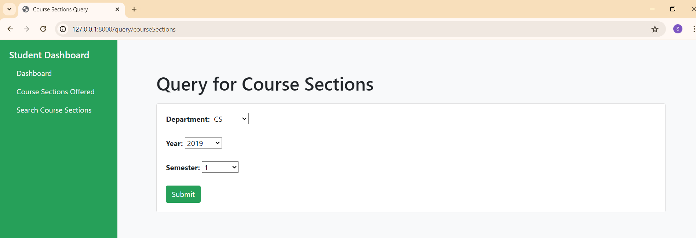

Select the department, academic year, and semester for viewing available course sections and click submit.After clicking submit, you will be redirected to the 'courseSections' page, where you can view a list of available course sections based on your search criteria.

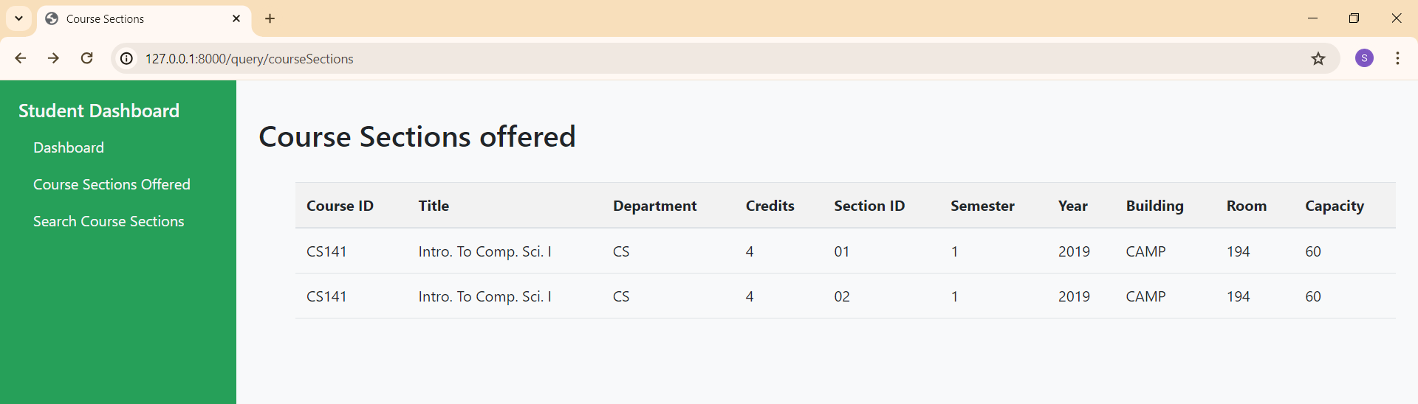

Logout: Clicking on this link will redirect you to the login page of our website, allowing you to securely sign out of your account.